Parabol

Definition
# Source: AI Source: Provided by: [Data Path: Persons Table -> ID Column: 1, Name_En Column: Motasem Essam] -> From: [ChatGPT] on [7/25/2026]
A parabola is a conic section consisting of all points in a plane that are equidistant from a fixed point and a fixed line.
The fixed point is called the focus, and the fixed line is called the directrix.
For any point $P$on a parabola:
$$\boxed{PF=\text{distance}\left(P , \text{directrix}\right)}$$
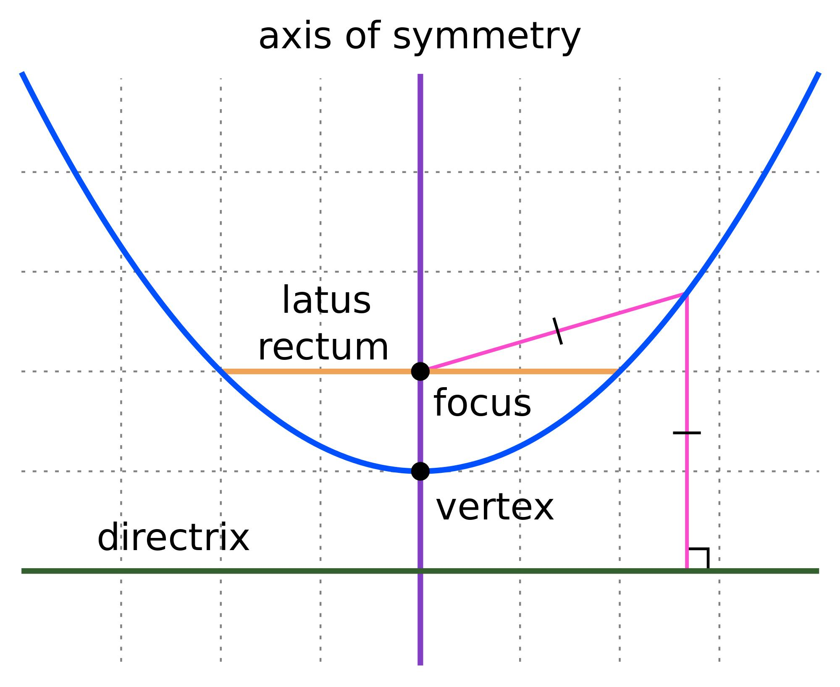
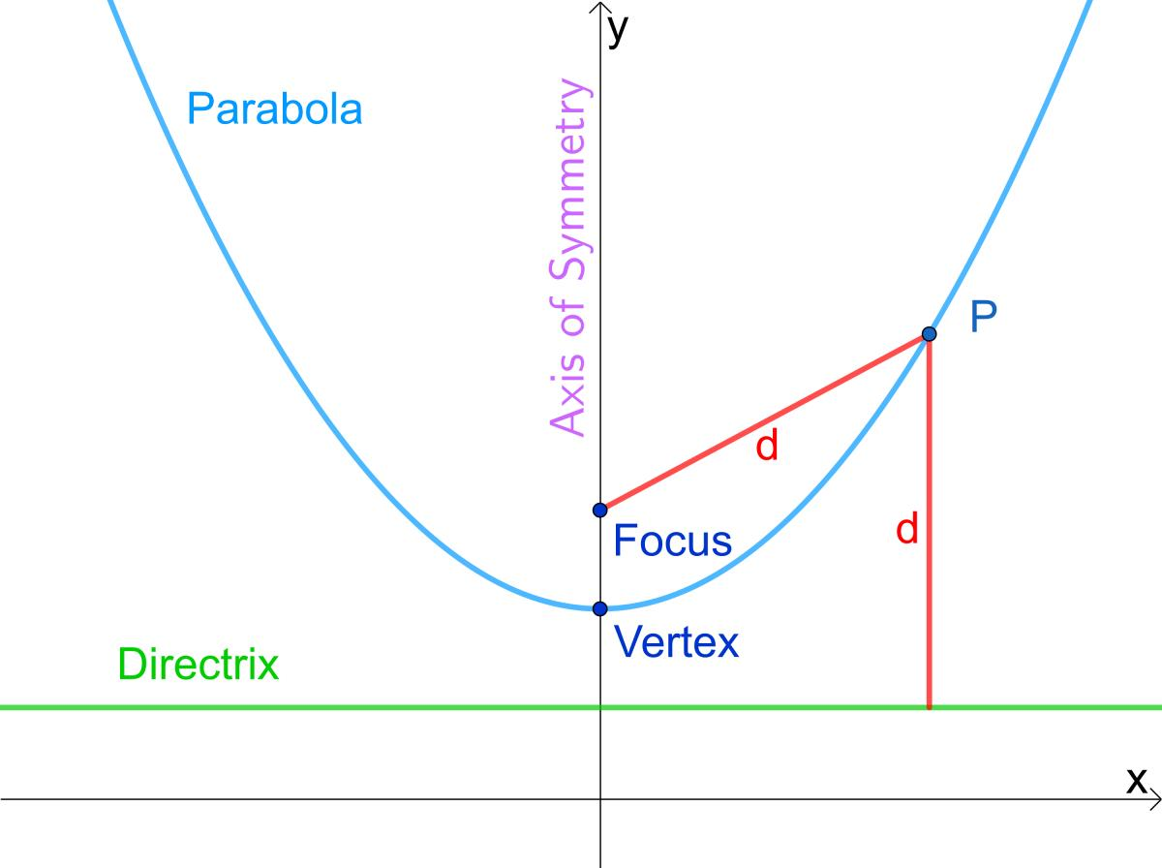
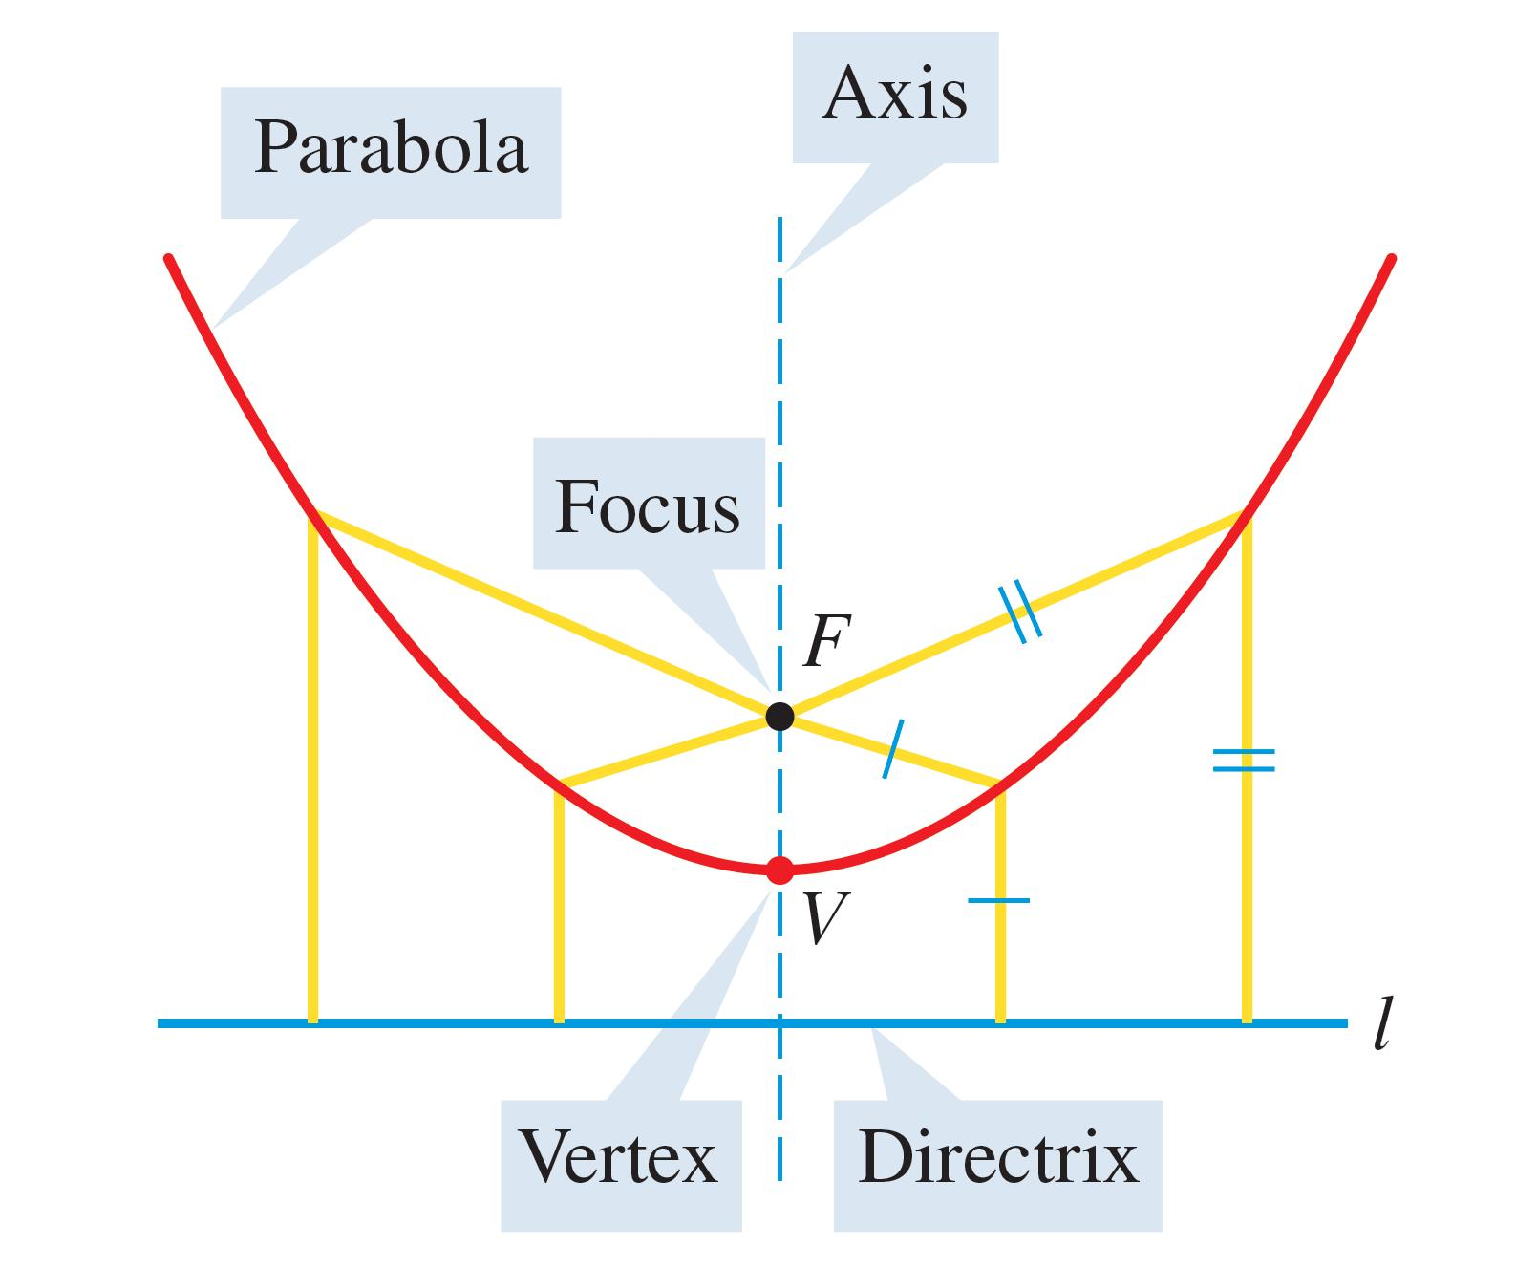
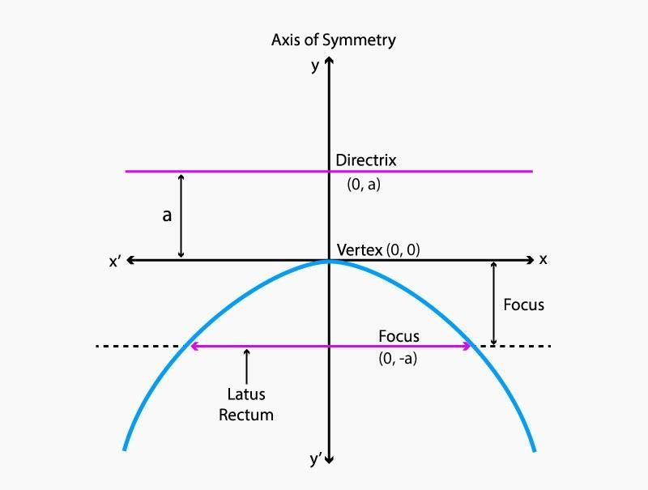
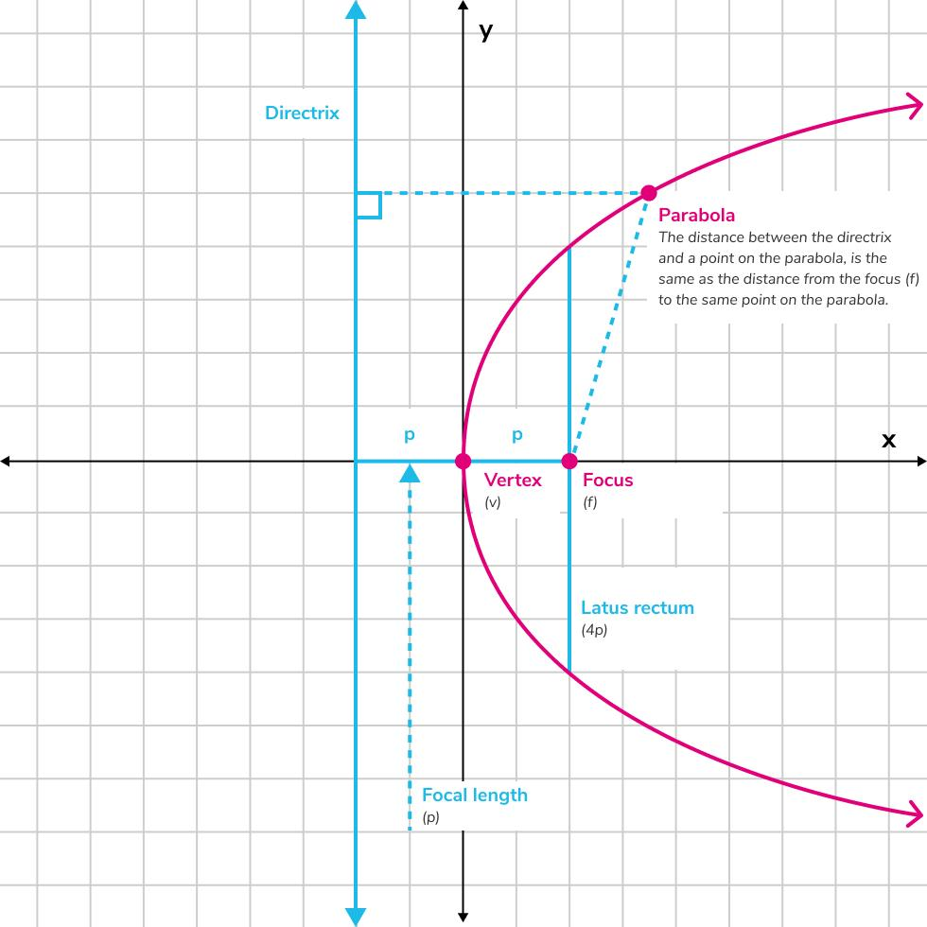

Fundamental Elements
# Source: AI Source: Provided by: [Data Path: Persons Table -> ID Column: 1, Name_En Column: Motasem Essam] -> From: [ChatGPT] on [7/25/2026]
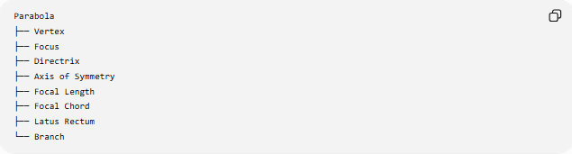
Parabola
├── Vertex
├── Focus
├── Directrix
├── Axis of Symmetry
├── Focal Length
├── Focal Chord
├── Latus Rectum
└── Branch
1. Vertex
The vertex is the point where the parabola changes direction.
It is the point closest to the directrix and focus along the axis of symmetry.
For a vertical parabola:
$$\boxed{V=\left(h , k\right)}$$
2. Focus
The focus is a fixed point associated with the parabola.
For:
$${\left(x-h\right)}^{2}=4p\left(y-k\right)$$
the focus is:
$$\boxed{F=\left(h , k+p\right)}$$
3. Directrix
The directrix is a fixed line.
For:
$${\left(x-h\right)}^{2}=4p\left(y-k\right)$$
the directrix is:
$$\boxed{y=k-p}$$
4. Axis of Symmetry
The axis of symmetry is the line that divides the parabola into two mirror-image halves.
For a vertical parabola:
$$\boxed{x=h}$$
For a horizontal parabola:
$$\boxed{y=k}$$
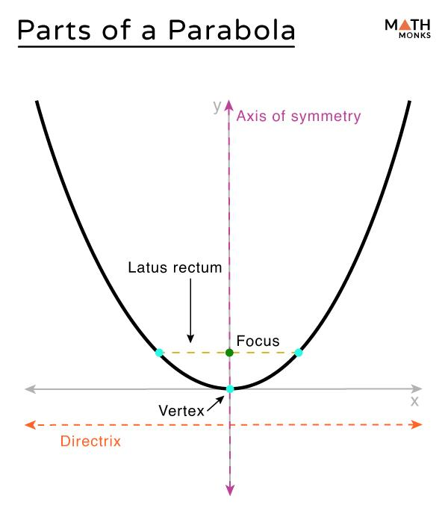
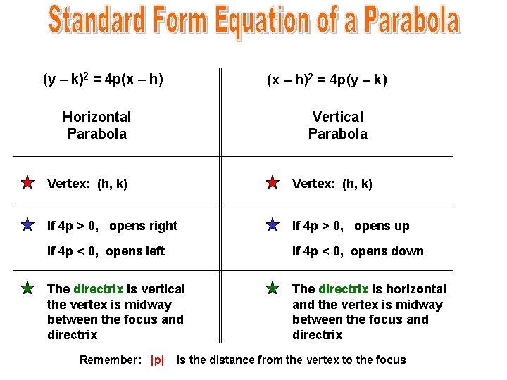
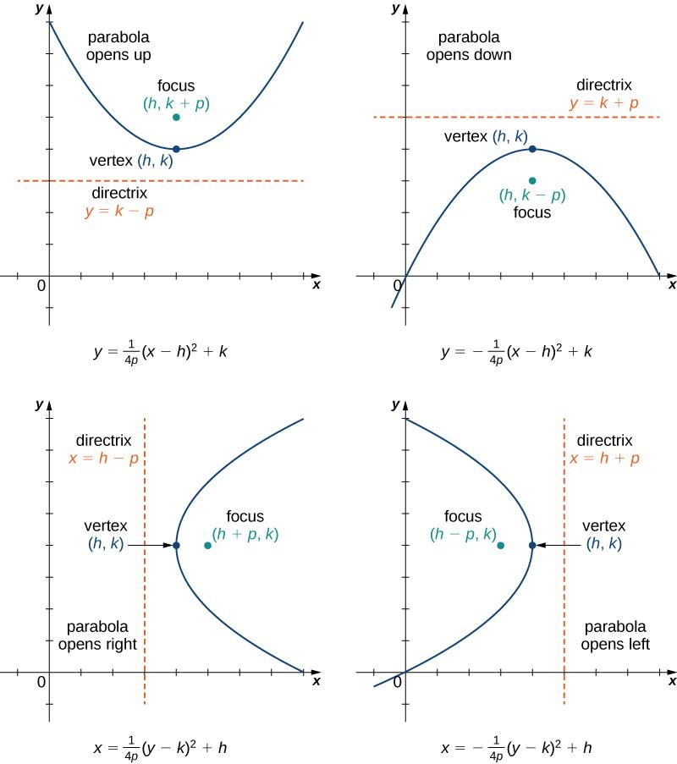
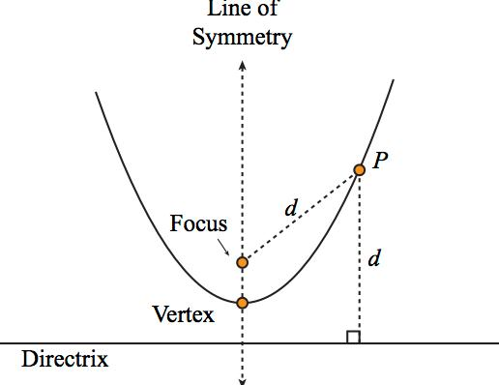
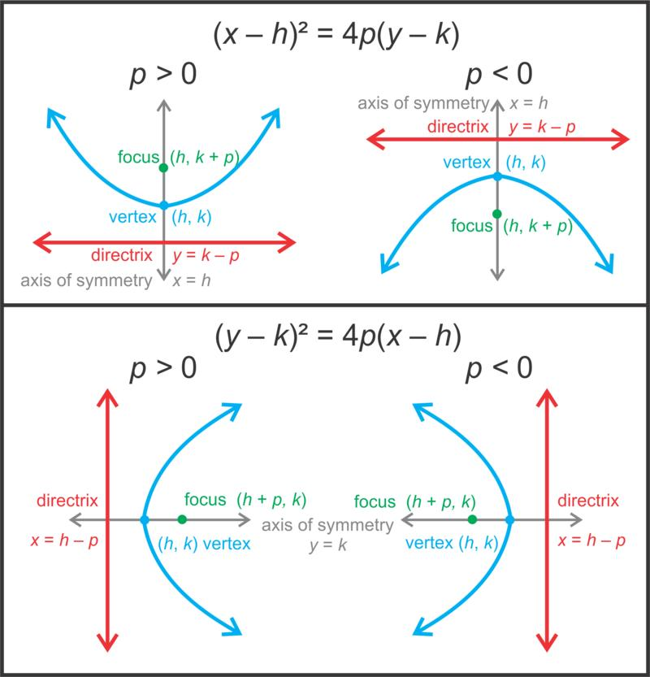

Eccentricity
# Source: AI Source: Provided by: [Data Path: Persons Table -> ID Column: 1, Name_En Column: Motasem Essam] -> From: [ChatGPT] on [7/25/2026]
The eccentricity of a parabola is exactly:
$$\boxed{e=1}$$
This means that for every point $P$on the parabola:
$$\boxed{\frac{\text{distance from }P\text{ to focus}}{\text{distance from }P\text{ to directrix}}=1}$$
Therefore:
$$\boxed{PF=\text{distance}\left(P , \text{directrix}\right)}$$
This is what distinguishes the parabola from the other principal conic sections.
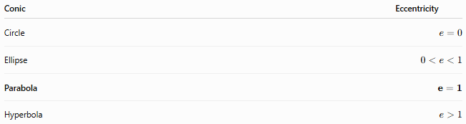
Conic | Eccentricity
Circle | $$e=0$$
Ellipse | $$0<e<1$$
Parabola | $$e=1$$
Hyperbola | $$e>1$$

Standard Equations

Vertical Parabola
# Source: AI Source: Provided by: [Data Path: Persons Table -> ID Column: 1, Name_En Column: Motasem Essam] -> From: [ChatGPT] on [7/25/2026]
$$\boxed{{\left(x-h\right)}^{2}=4p\left(y-k\right)}$$
where:
- $\left(h , k\right)$= vertex
- $p$= directed distance from vertex to focus.
If $p>0$
The parabola opens upward.
Focus:
$$\boxed{\left(h , k+p\right)}$$
Directrix:
$$\boxed{y=k-p}$$
If $p<0$
The parabola opens downward.

Horizontal Parabola
# Source: AI Source: Provided by: [Data Path: Persons Table -> ID Column: 1, Name_En Column: Motasem Essam] -> From: [ChatGPT] on [7/25/2026]
$$\boxed{{\left(y-k\right)}^{2}=4p\left(x-h\right)}$$
If $p>0$
The parabola opens right.
Focus:
$$\boxed{\left(h , +pk\right)}$$
Directrix:
$$\boxed{x=h-p}$$
If $p<0$
The parabola opens left.
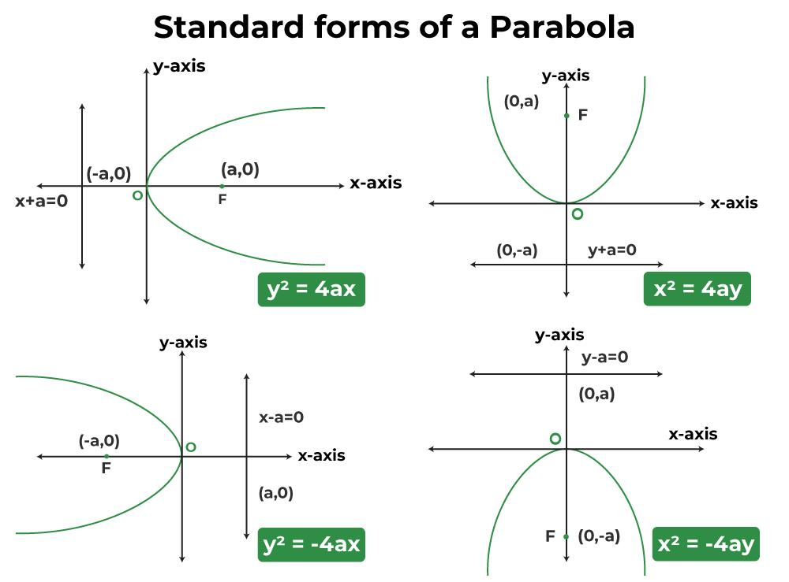
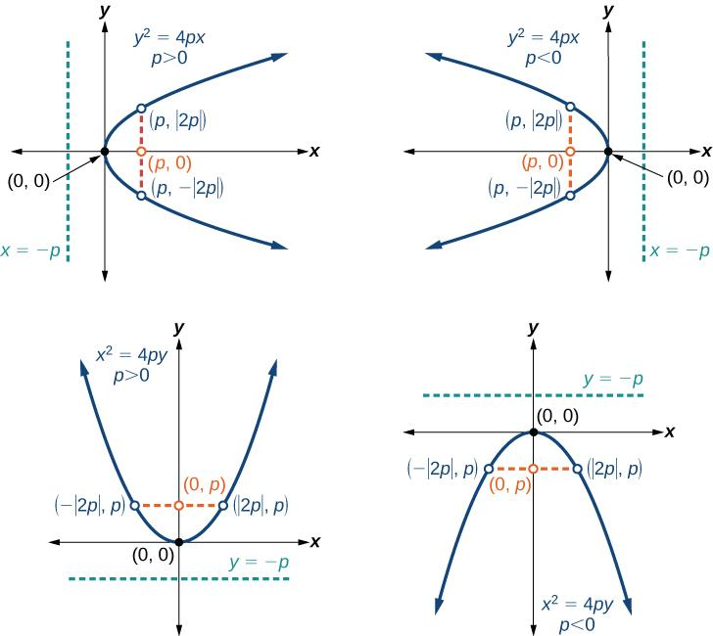
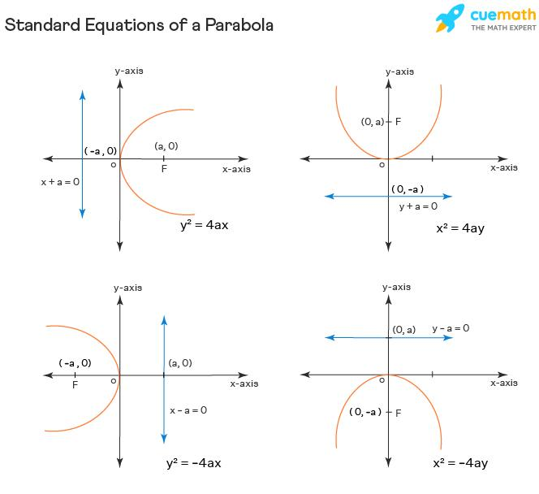
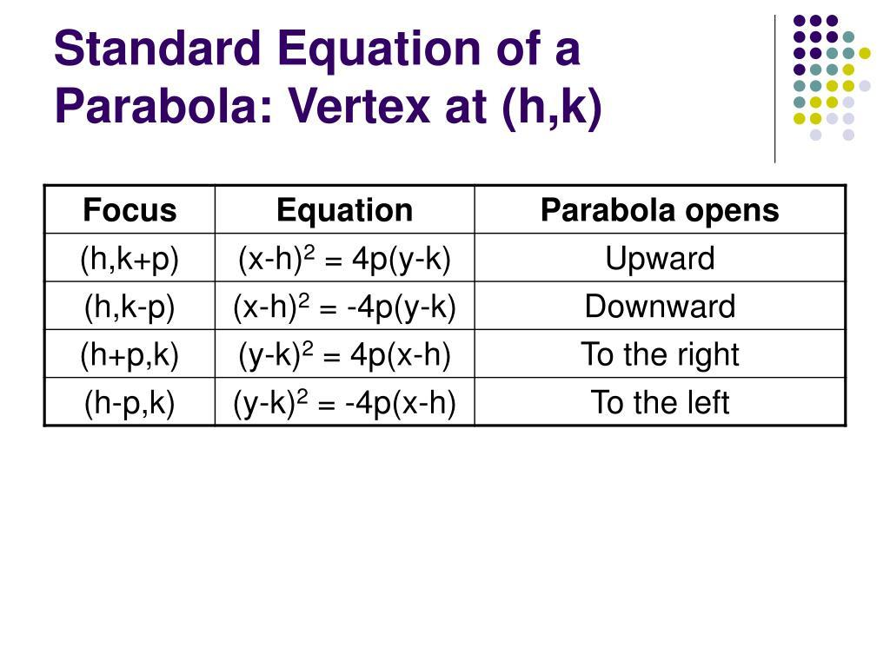

Vertex Form
# Source: AI Source: Provided by: [Data Path: Persons Table -> ID Column: 1, Name_En Column: Motasem Essam] -> From: [ChatGPT] on [7/25/2026]
A vertical parabola can also be written as:
$$\boxed{y=a{\left(x-h\right)}^{2}+k}$$
where:
$$\boxed{\left(h , k\right)}$$
is the vertex.
Direction of Opening
If:
$$a>0$$
the parabola opens upward.
If:
$$a<0$$
the parabola opens downward.
The relationship between $a$and $p$is:
$$\boxed{a=\frac{1}{4p}}$$

Focus-Directrix Property
# Source: AI Source: Provided by: [Data Path: Persons Table -> ID Column: 1, Name_En Column: Motasem Essam] -> From: [ChatGPT] on [7/25/2026]
The defining property of a parabola is:
$$\boxed{PF=d\left(P , \text{directrix}\right)}$$
For example, if the focus is $F$and the directrix is $l$, every point $P$on the parabola satisfies:
$$\boxed{PF=d\left(P , l\right)}$$
This property can be used to construct a parabola geometrically.

Latus Rectum
# Source: AI Source: Provided by: [Data Path: Persons Table -> ID Column: 1, Name_En Column: Motasem Essam] -> From: [ChatGPT] on [7/25/2026]
The latus rectum is a chord of the parabola that:
- passes through the focus,
- is perpendicular to the axis of symmetry.
Its length is:
$$\boxed{4∣p∣}$$
For example, if:
$$p=3$$
then:
$$\boxed{\text{Latus rectum}=12}$$
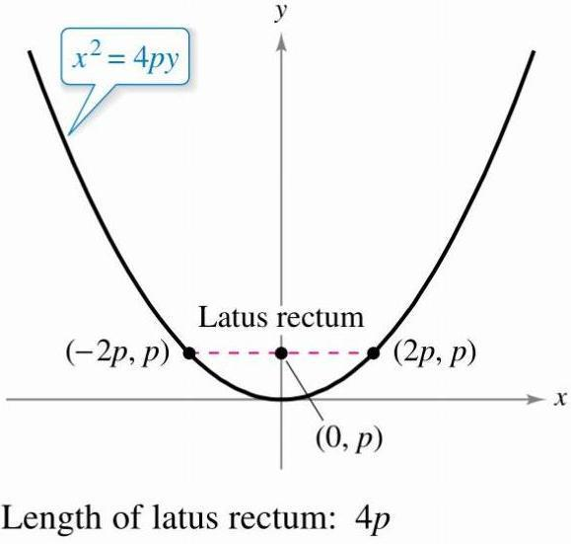
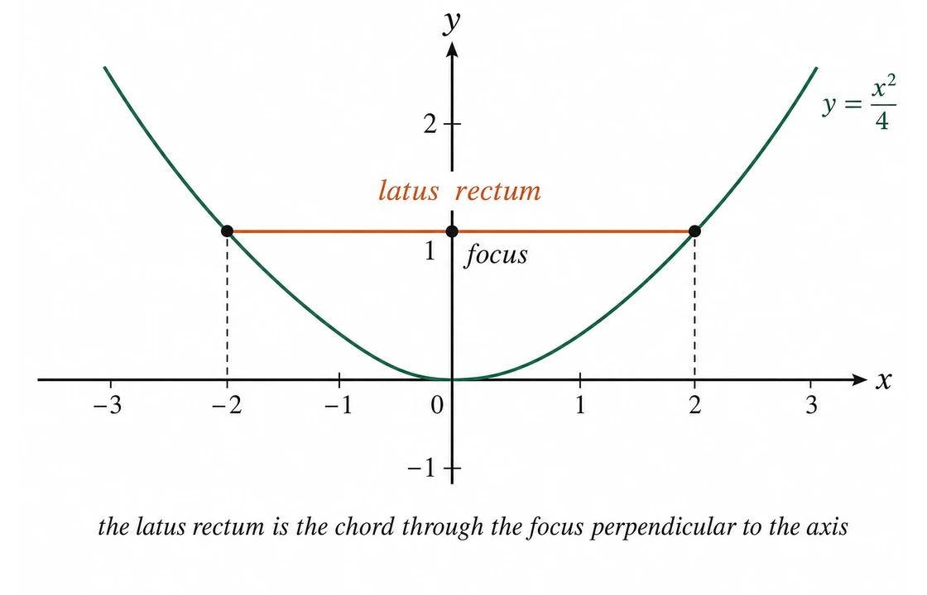
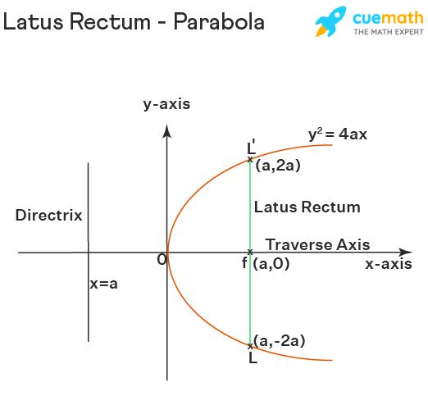

Main Properties
# Source: AI Source: Provided by: [Data Path: Persons Table -> ID Column: 1, Name_En Column: Motasem Essam] -> From: [ChatGPT] on [7/25/2026]
- A parabola is a conic section.
- It is an open curve.
- It has one continuous branch.
- It has exactly one focus.
- It has exactly one directrix.
- Every point on the parabola is equidistant from the focus and directrix.
- It has one axis of symmetry.
- It has one vertex.
- Its eccentricity is exactly:
$$\boxed{e=1}$$
- It extends infinitely in the direction in which it opens.
- It has no center of symmetry.
- It has no asymptotes.
- Its latus rectum has length $4∣p∣$.

Types of Parabolas
# Source: AI Source: Provided by: [Data Path: Persons Table -> ID Column: 1, Name_En Column: Motasem Essam] -> From: [ChatGPT] on [7/25/2026]
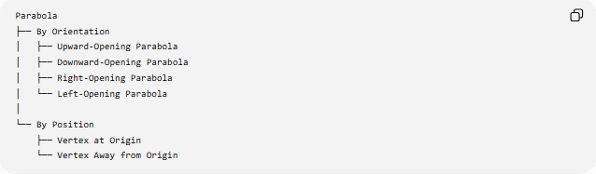
Parabola
├── By Orientation
│ ├── Upward-Opening Parabola
│ ├── Downward-Opening Parabola
│ ├── Right-Opening Parabola
│ └── Left-Opening Parabola
│
└── By Position
├── Vertex at Origin
└── Vertex Away from Origin

Parabola with Vertex at the Origin
# Source: AI Source: Provided by: [Data Path: Persons Table -> ID Column: 1, Name_En Column: Motasem Essam] -> From: [ChatGPT] on [7/25/2026]
If:
$$\left(h , k\right)=\left(0 , 0\right)$$
then the standard equations become:
Vertical
$$\boxed{x^{2}=4py}$$
Horizontal
$$\boxed{y^{2}=4px}$$
For example:
$$x^{2}=8y$$
gives:
$$4p=8$$
so:
$$p=2$$
Therefore:
- Vertex: $\left(0 , 0\right)$
- Focus: $\left(0 , 2\right)$
- Directrix: $y=-2$

Example
# Source: AI Source: Provided by: [Data Path: Persons Table -> ID Column: 1, Name_En Column: Motasem Essam] -> From: [ChatGPT] on [7/25/2026]
Consider:
$${\left(x-2\right)}^{2}=12\left(y+1\right)$$
Compare with:
$${\left(x-h\right)}^{2}=4p\left(y-k\right)$$
Therefore:
$$h=2 \\ k=-1$$
and:
$$4p=12$$
so:
$$p=3$$
Vertex
$$\boxed{\left(2 , -1\right)}$$
Focus
$$\left(h , k+p\right) \\ =\left(2 , -1+3\right) \\ \boxed{\left(2 , 2\right)}$$
Directrix
$$y=k-p \\ y=-1-3 \\ \boxed{y=-4}$$
The parabola opens upward.

Reflection Property
# Source: AI Source: Provided by: [Data Path: Persons Table -> ID Column: 1, Name_En Column: Motasem Essam] -> From: [ChatGPT] on [7/25/2026]
The parabola has an important reflection property.
A ray traveling parallel to the axis of symmetry and reflecting from the parabola passes through the focus.
Conversely, a ray originating from the focus and reflecting from the parabola travels parallel to the axis.
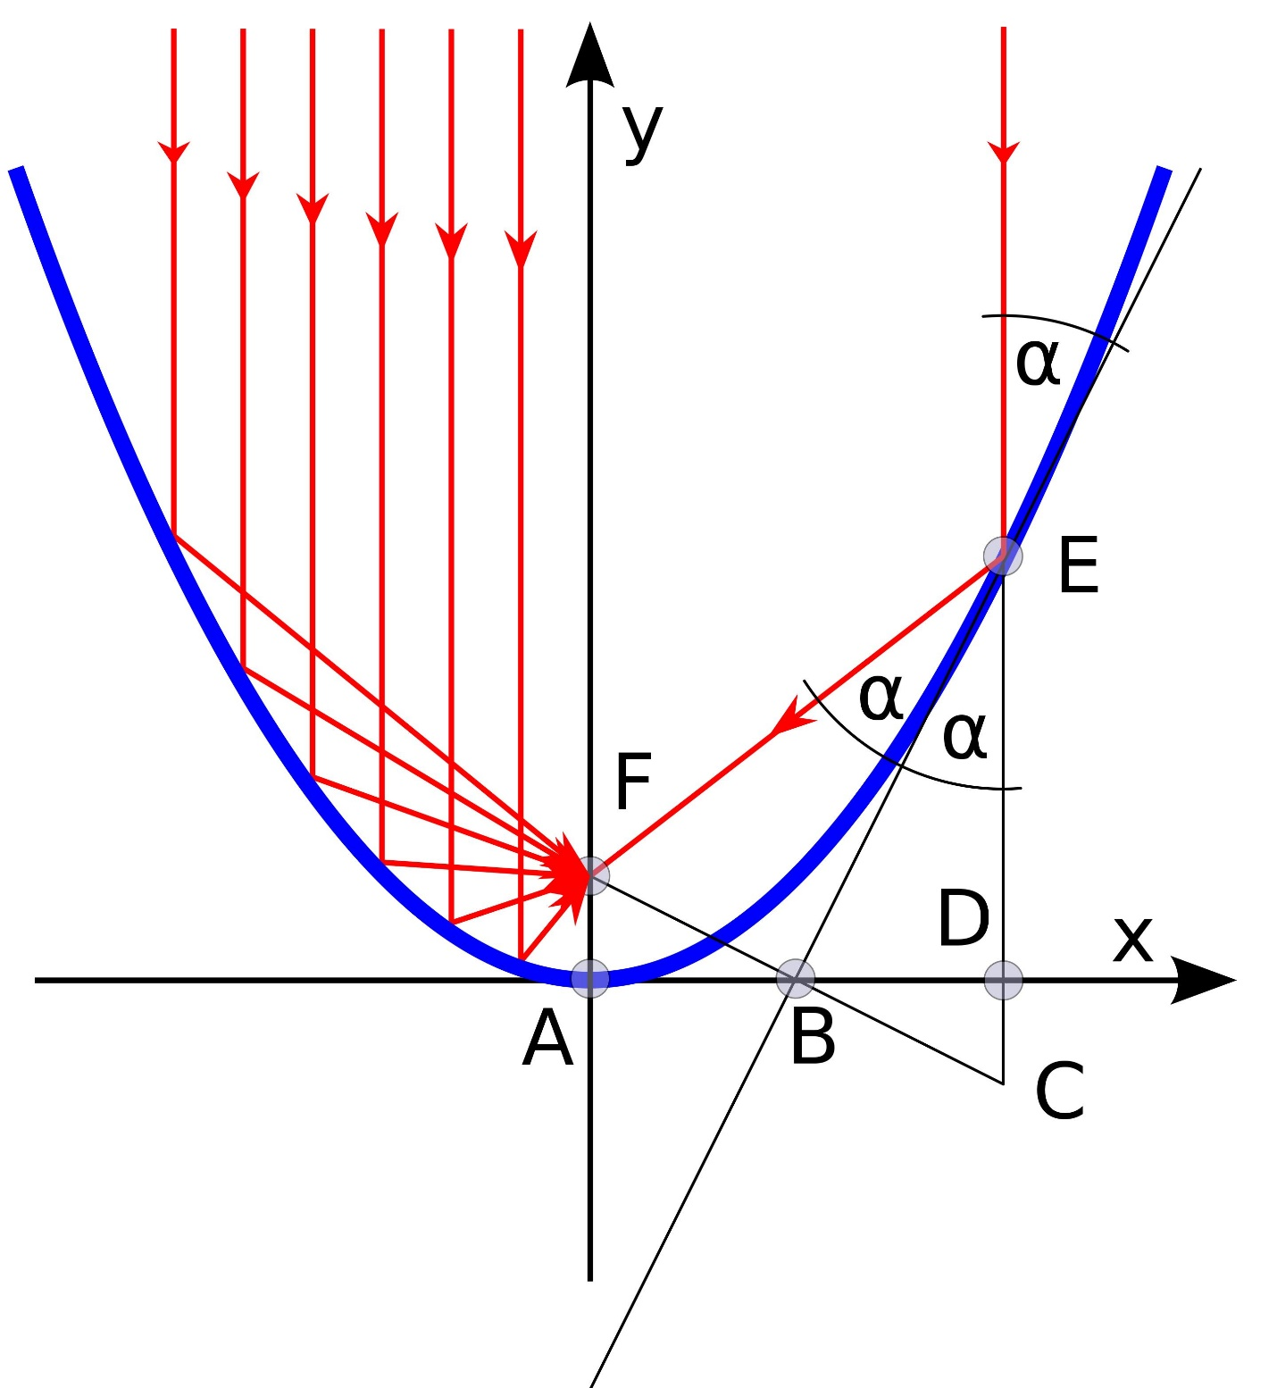
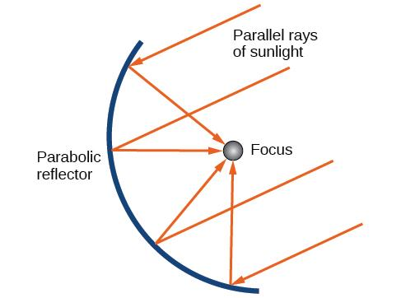
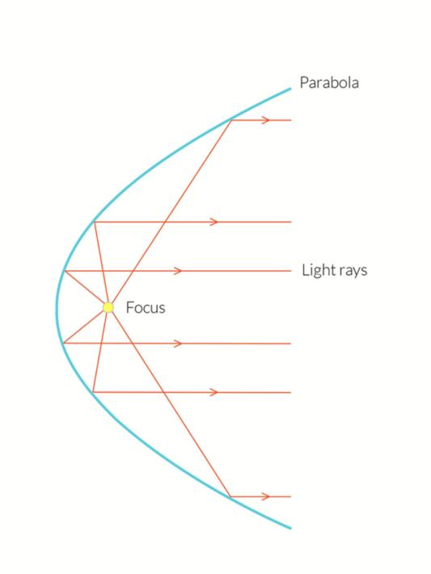
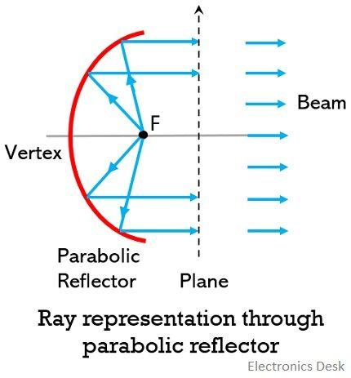
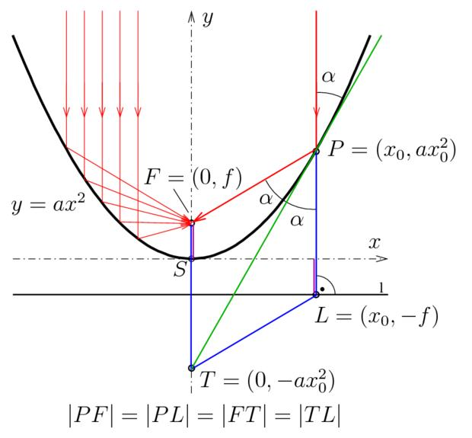
This property is important in many practical applications.

Parabola vs. Other Conic Sections
# Source: AI Source: Provided by: [Data Path: Persons Table -> ID Column: 1, Name_En Column: Motasem Essam] -> From: [ChatGPT] on [7/25/2026]
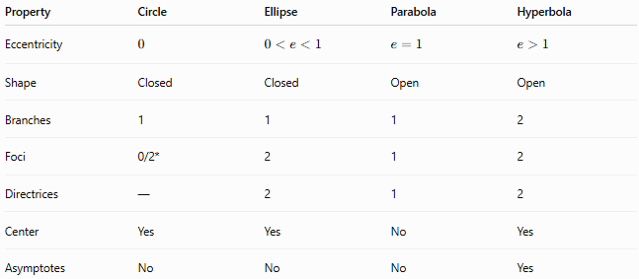
Property | Circle | Ellipse | Parabola | Hyperbola
Eccentricity | $$0$$ | $$0<e<1$$ | $$e=1$$ | $$e>1$$
Shape | Closed | Closed | Open | Open
Branches | 1 | 1 | 1 | 2
Foci | 0/2* | 2 | 1 | 2
Directrices | — | 2 | 1 | 2
Center | Yes | Yes | No | Yes
Asymptotes | No | No | No | Yes
$*$A circle is the special case of an ellipse where the two foci coincide at the center.

Relationship with Conic Sections
# Source: AI Source: Provided by: [Data Path: Persons Table -> ID Column: 1, Name_En Column: Motasem Essam] -> From: [ChatGPT] on [7/25/2026]
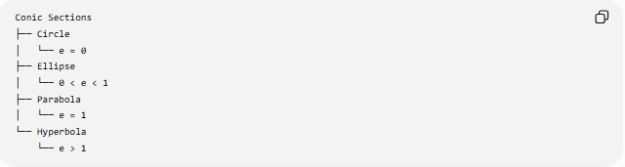
Conic Sections
├── Circle
│ └── e = 0
├── Ellipse
│ └── 0 < e < 1
├── Parabola
│ └── e = 1
└── Hyperbola
└── e > 1
The parabola represents the boundary case between ellipse-type and hyperbola-type eccentricities.

Real-World Applications
# Source: AI Source: Provided by: [Data Path: Persons Table -> ID Column: 1, Name_En Column: Motasem Essam] -> From: [ChatGPT] on [7/25/2026]
The reflection property of parabolas makes them useful in:
- Satellite dishes
- Radio telescopes
- Car headlights
- Searchlights
- Solar concentrators
- Microwave antennas
- Acoustic reflectors
- Architectural structures
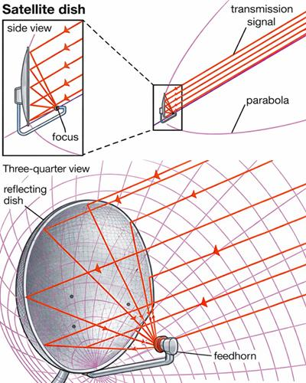
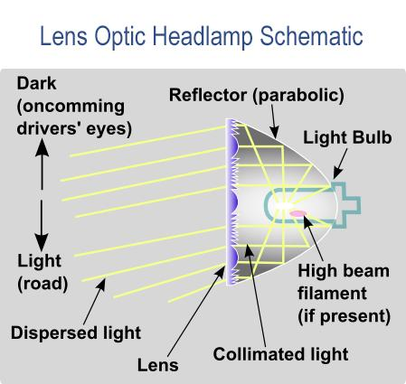
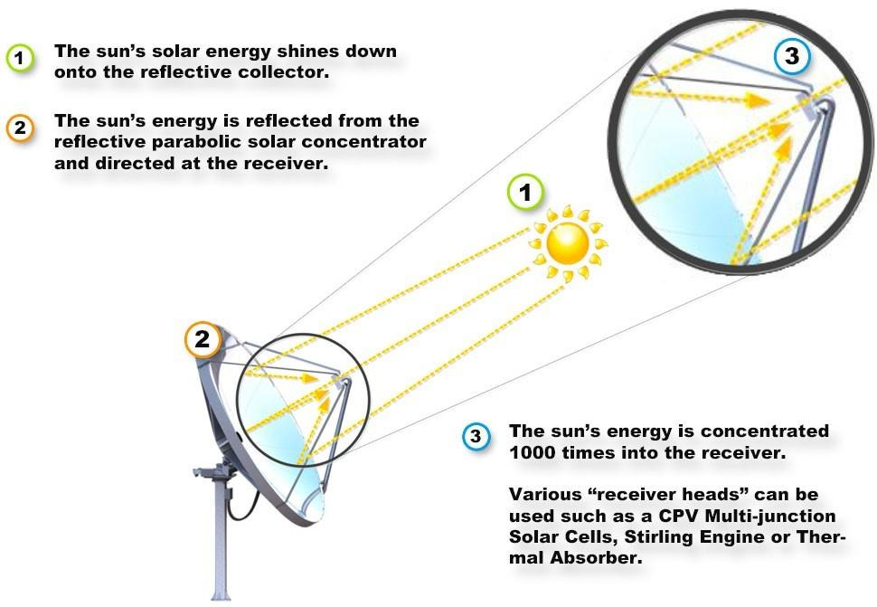
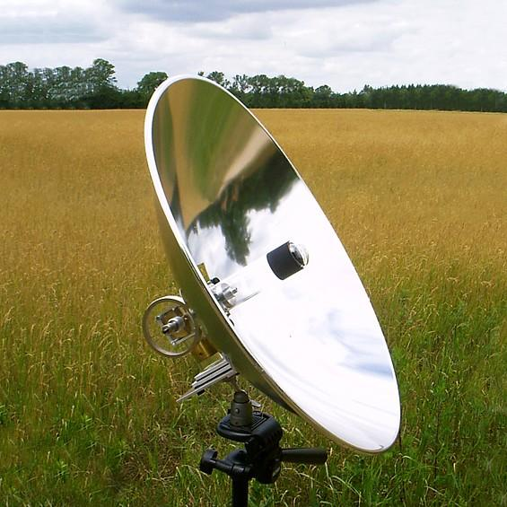
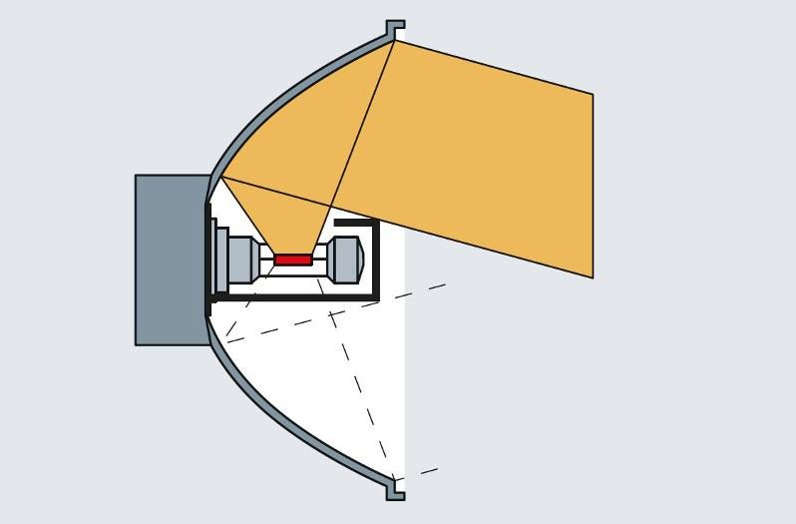

Key Formulas
# Source: AI Source: Provided by: [Data Path: Persons Table -> ID Column: 1, Name_En Column: Motasem Essam] -> From: [ChatGPT] on [7/25/2026]
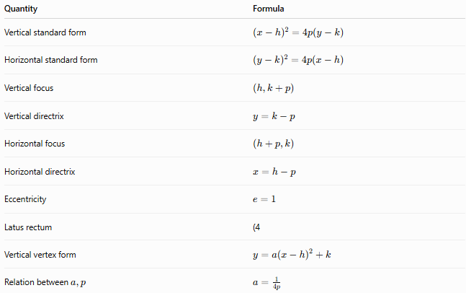
Quantity | Formula
Vertical standard form | $${\left(x-h\right)}^{2}=4p\left(y-k\right)$$
Horizontal standard form | $${\left(y-k\right)}^{2}=4p\left(x-h\right)$$
Vertical focus | $$\left(h , k+p\right)$$
Vertical directrix | $$y=k-p$$
Horizontal focus | $$\left(h , +pk\right)$$
Horizontal directrix | $$x=h-p$$
Eccentricity | $$e=1$$
Latus rectum | (4
Vertical vertex form | $$y=a{\left(x-h\right)}^{2}+k$$
Relation between $a,p$ | $$a=\frac{1}{4p}$$

Key Points
# Source: AI Source: Provided by: [Data Path: Persons Table -> ID Column: 1, Name_En Column: Motasem Essam] -> From: [ChatGPT] on [7/25/2026]
- A parabola is an open conic section.
- It has one focus and one directrix.
- Every point on it is equally distant from the focus and directrix.
- Its eccentricity is:
$$\boxed{e=1}$$
- It has one axis of symmetry and one vertex.
- It has no center.
- It has no asymptotes.
- Its defining distance property is:
$$\boxed{PF=d\left(P , \text{directrix}\right)}$$

Conclusion
# Source: AI Source: Provided by: [Data Path: Persons Table -> ID Column: 1, Name_En Column: Motasem Essam] -> From: [ChatGPT] on [7/25/2026]
A parabola is the conic section defined by the equality of the distance from a point to a fixed focus and its perpendicular distance to a fixed directrix.
Its defining characteristics are:
$$\boxed{e=1} \\ \boxed{PF=d\left(P , \text{directrix}\right)}$$
and its standard forms are:
$$\boxed{{\left(x-h\right)}^{2}=4p\left(y-k\right)} \\ \boxed{{\left(y-k\right)}^{2}=4p\left(x-h\right)}$$
It is the only principal conic section with exactly one focus, one directrix, and eccentricity equal to 1.

